CNC Tubing Coper

Formula SAE is student design competition in which student-run teams from universities worldwide build small formula-style racecars to compete head to head. During my sophomore year of college, I joined our newly-formed team which, at the time, was in the process of designing their first car.
I was eager to help in any way I could in order to get our racecar design built. The club’s original plan for building the car was to use a tube coping jig consisting of a drill, a hole saw, and a clamp. There were dozens of cuts to be made and early testing revealed that small errors made during this process stacked up. This resulted in the chassis of the car being asymmetrical and difficult to weld.
I instead proposed we build a CNC, or computer controlled, machine to aid in coping the tubing with a much higher accuracy than manually aligning and drilling each piece of tubing. While there are pre-existing services that do this, our club had very little money and could not afford to outsource tubing cutting and coping. We were also having a difficult time finding sponsors as it was a new club and we had nothing to show for our efforts besides a SolidWorks model.
I reasoned that we could use a cheap CNC kit that would come with the barebones parts to get us up and running. In addition, the frame could be constructed out of cheap aluminum extrusion and a couple of custom laser-cut end pieces. This is what we ultimately decided to move forward with. With our limited budget, we bought a two-axis DIY CNC kit containing two stepper motors, two stepper drivers, a Mach3 CNC board, and some other miscellaneous hardware.
I designed the machine in Fusion 360 and ordered the custom end plates for the chassis of the machine. I knew that the longest piece of continuous tubing on the car was just under one meter, so I designed the machine to be long enough to cut both ends of the tub in one go, eliminating the need to re-index the tube in between cuts. I also used the CNC router in our campus makerspace to cut several more pieces for the machine, namely a custom motor mount and the trolley on which the plasma torch was to be mounted.
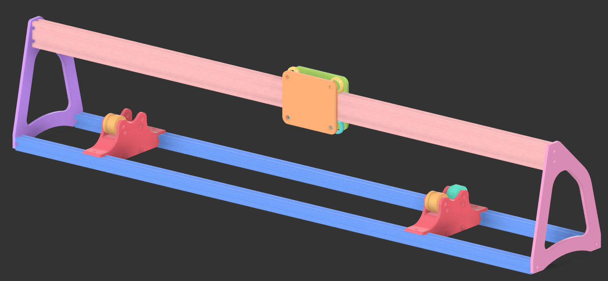
Tubing Coper CAD Model
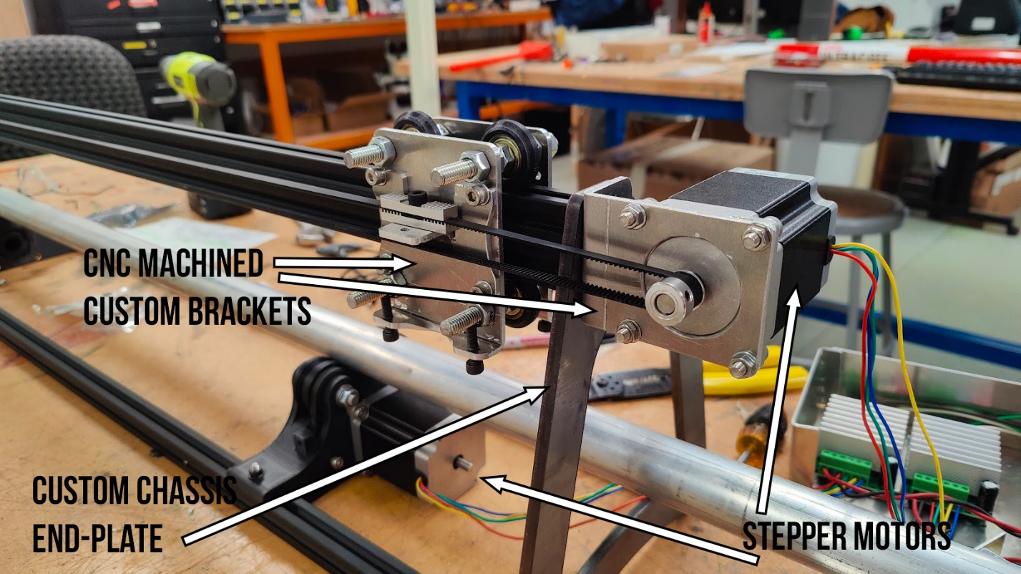
CNC Tubing Coper
Under a tight time crunch and before I had to leave for spring break, I had a friend and fellow club member help with the wiring and software setup while I moved on to assembling the machine and machining the remaining parts. Ultimately, this was the last time I got to work on my creation as I had to turn it over to the chassis team of the club where they mounted the plasma torch and calibrated it. They shared with me that it was performing test cuts and working well, and that they hope to start the chassis build this coming semester (Fall 2025)

